**ADVANCE EXCEL ASSIGNMENT 02**

**1.What does the dollar($) sign do?**

In Excel, a dollar sign can denote a currency format, but it has another common use: indicating absolute cell references in formulas.

**2. How to Change the Reference from Relative to Absolute (or Mixed)?**

* Select the cell that contains the formula.
* In the formula bar. , select the reference that you want to change.
* Press F4 to switch between the reference types.

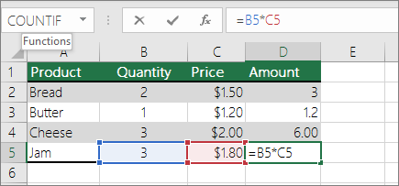

**3. Explain the order of operations in excel?**

In general, Excel's order of operation follows the acronym **PEMDAS (Parentheses, Exponents, Multiplication, Division, Addition, Subtraction)** but with some customization to handle the formula syntax in a spreadsheet. First, any expressions in parentheses are evaluated and so on.

**4. What, according to you, are the top 5 functions in excel and write a basic syntax for any of two?**

The top 5 functions of excel are given belows

The ***sum*** Function.

The ***text*** Function. ...

The ***vlookup*** Function. ...

The ***average*** Function. ...

The ***concatenate*** Function.

The syntax formula for **sum** function is “=SUM” (number1, number2, etc.)

The syntax formula for *text*function is “=TEXT” (value, format text).

* “Value” refers to the particular number you wish to convert to text.
* “Format text” defines the format of the conversion.

**5. When would you use the subtotal function?**

The **SUBTOTAL** function is designed for columns of data, or vertical ranges. It is not designed for rows of data, or horizontal ranges.

**SUBTOTAL** help us to get the totals of several columns of data broken down into various categories.

For example, let's consider garment products of different sizes manufactured. The **SUBTOTAL** function will help you to get a count of different sizes in your warehouse.

**6. What is the syntax of the vlookup function? Explain the terms in it?**

The **VLOOKUP** function is a premade function in Excel, which allows searches across columns.

Syntax for **VLOOKUP** is “=**VLOOKUP**(**lookup_value**, **table_array**, **col_index_num**, [**range_lookup**])”

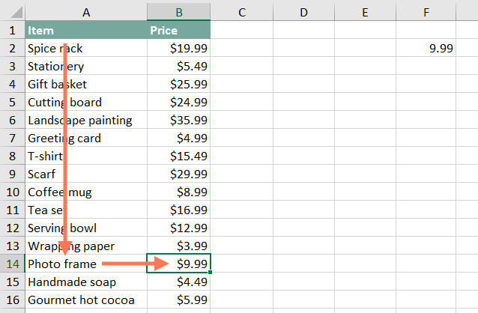

We're going to use **VLOOKUP** to find the price of the **Photo frame**.

It first **searches vertically** down the first column (**VLOOKUP** is short for **vertical lookup**). When it finds "Photo frame", it **moves to the second column** to find the price.

The first argument is the name of the item you're searching for, which in this case is Photo frame. Because the argument is text, we'll need to put it in double quotes:

=**VLOOKUP**("Photo frame"

The second argument is the cell range that contains the data. In this example, our data is in A2:B16. As with any function, you'll need to use a comma to separate each argument:

=VLOOKUP("Photo frame", A2:B16

It's important to know that VLOOKUP will always search the first column in this range. In this example, it will search column A for "Photo frame". The value that it returns (in this case, the price) will always need to be to the right of that column.

The third argument is the column index number. It's simpler than it sounds: The first column in the range is 1, the second column is 2, etc. In this case, we are trying to find the price of the item, and the prices are contained in the second column. This means our third argument will be 2:

=VLOOKUP("Photo frame", A2:B16, 2

The fourth argument tells VLOOKUP whether to look for approximate matches, and it can be either TRUE or FALSE. If it is TRUE, it will look for approximate matches. Generally, this is only useful if the first column has numerical values that have been sorted. Because we're only looking for exact matches, the fourth argument should be FALSE. This is our last argument, so go ahead and close the parentheses:

**=VLOOKUP("Photo frame", A2:B16, 2, FALSE)**

That's it! When you press Enter, it should give you the answer, which is 9.99.